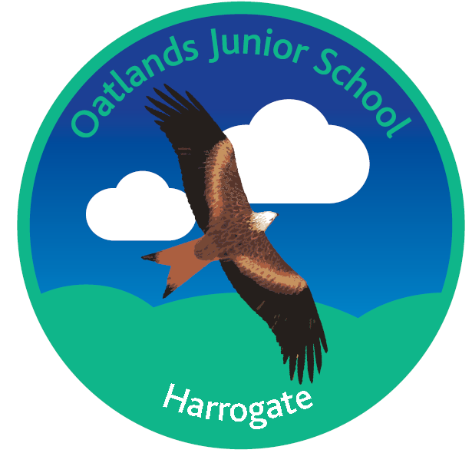

Handwriting and Presentation Guidance

National Curriculum 2014
In Key Stage 2 handwriting is non-statutory. In Years 3 and 4: ‘Handwriting should continue to be taught’ and Years 5 and 6: ‘Should continue to practise handwriting’.

End of KS2 Teacher Assessment Frameworks 201-19
WORKING AT THE EXPECTED STANDARD IN WRITING
‘The pupil can maintain legibility, fluency and speed in handwriting through choosing whether or not to join specific letters.’

Ofsted Subject Specific Guidance: English
For the achievement of pupils to be graded as outstanding; ‘Pupils must make sustained progress in learning to read and to write legibly and fluently.’ (English Survey Visits. April 2014).

At Oatlands Junior School, our expectations for HANDWRITING are:

- Twinkl Continuous Cursive is the scheme currently used at OJS. This is to provide consistency and progression from what the children are taught at Oatlands Infants. A 20-30 minute session per week for explicit teaching, practising and applying handwriting skills, should be planned for.
- All year groups use A4 paper with printed guidelines for handwriting practice. This is kept in red plastic folders.
- At the start of each academic year, all children will write the school values using handwriting pens in their handwriting books. In addition to this, a poem or relevant piece of writing will be copied neatly onto the front page in English books, using handwriting pens. This, along with the Summer Holiday recount, also written in handwriting pen (except Y3), will allow new teachers to assess the standard of handwriting and reiterate the high expectations to their new class.
- It is the expectation that most children will achieve their ‘Pen Licence’ in Year 3 and so from Y4 onwards, all children should be writing in pen. Any children that have exceptional difficulties can continue in pencil.
- Handwriting pens are awarded once children demonstrate consistently, over time and in all books that they can write in a neat, fluent and legible style. This can be at any stage of ‘joining’ (i.e. letter forming, beginning, consistent). A blue ink handwriting pen will be usedin all books (except Maths). Each class teacher holds a stock of left handed Swanneck pens for those who need them.
- All children will have the opportunity to use pens in their handwriting folders, Creative Writing Journals and when presenting written work for display.
- Pupils who do not maintain neat handwriting and presentation may be asked write in pencil until such a time that this improves. This action will follow as a direct outcome from shared discussion with the child.

At Oatlands Junior School, our expectations for PRESENTATION are:
(See also Marking and Feedback policy).
- All books should have a typed label.
- Creative Writing Journals to contain the task glued before children’s work, to provide a context.
- All task sheets to be fully glued onto the page and not folded.
- Date and title/WALT underlined in all books, in pencil. Date written on the very top line on the left hand side; one line missed as a space before WALT written. The word WALT written in margin.
- For some LAP or children with SEND, the WALT can be written by an adult or printed on a sticker.
- In Maths books the number date should be written and ‘one digit in one box’ to ensure clear recording. One line missed after each question for clarity and as a space for corrections to be written.
- After a piece of writing, children to rule off if less than half a page. If not start a new page.
- Paragraphs should start after one missed line, to indicate clearly the start of a new one.
- Diagrams, pictures, label lines, borders and large title lettering should be drawn using pencil.
- Work should be marked in black pen and use the symbols from the Marking and Feedback policy. The same symbols should be used by the children when editing their writing. These symbols are displayed on A3 coloured posters in the classroom and on A5 cards accessible on desks.
- Self-marking and editing to be completed using purple pen.
- Mistakes are shown using one ruler line drawn with a pencil, by both staff and pupils. No rubbing out, unless for mistakes on diagrams or graphs.
- Pupil responses to marked work should take place before the start of the next lesson, during response to marking time and using the purple pen.
- Any PPA or supply staff should mark and initial in black pen (or stamp) work taught.
- Children should be using line guides whenever the child is working on plain paper (teacher discretion).

